Network Design Introduction
Our network design is built to provide a secure, reliable, and scalable infrastructure. It ensures efficient communication between devices, optimized performance, and easy future expansion while following industry best practices.

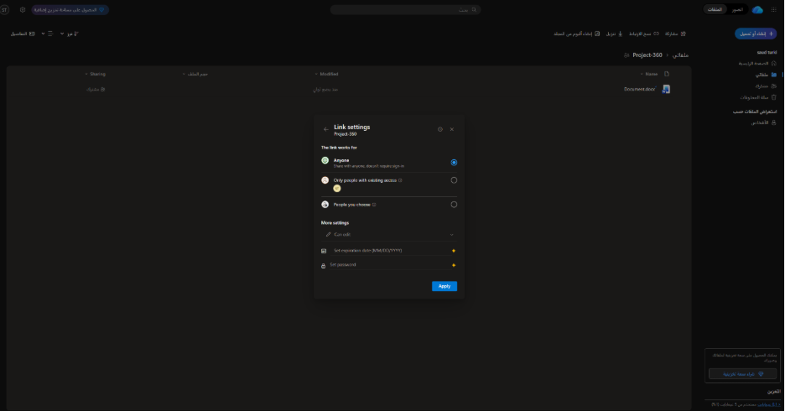
- we created sheered folder and the link
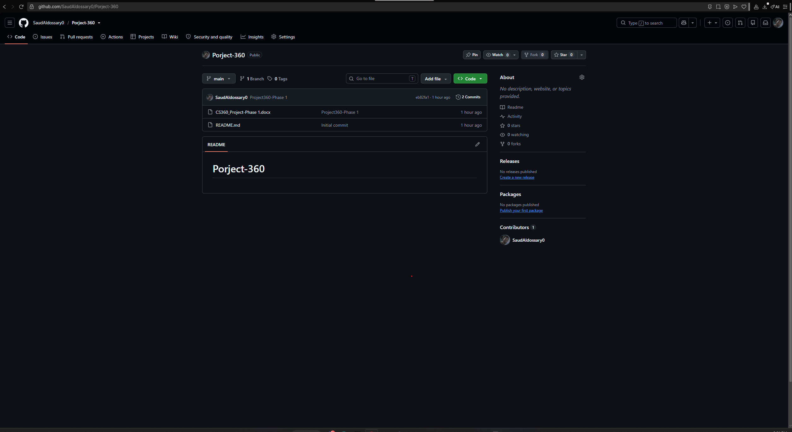
- we created repository for project_360
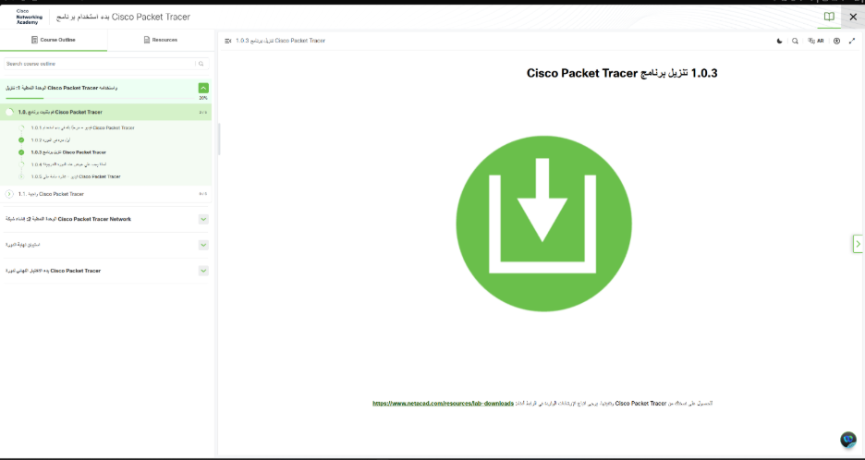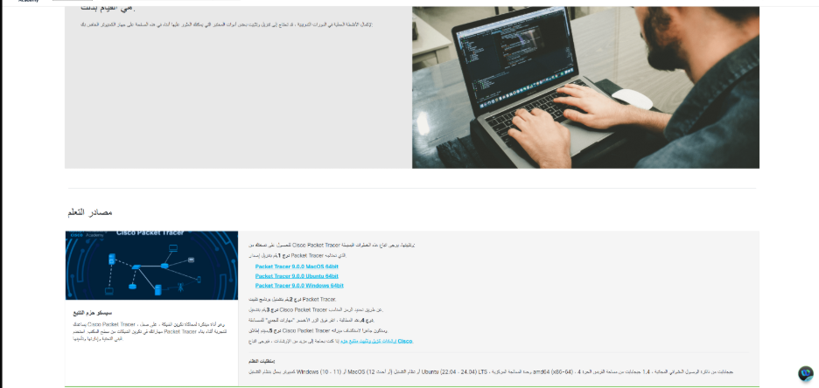
- Created a cisco network academy account
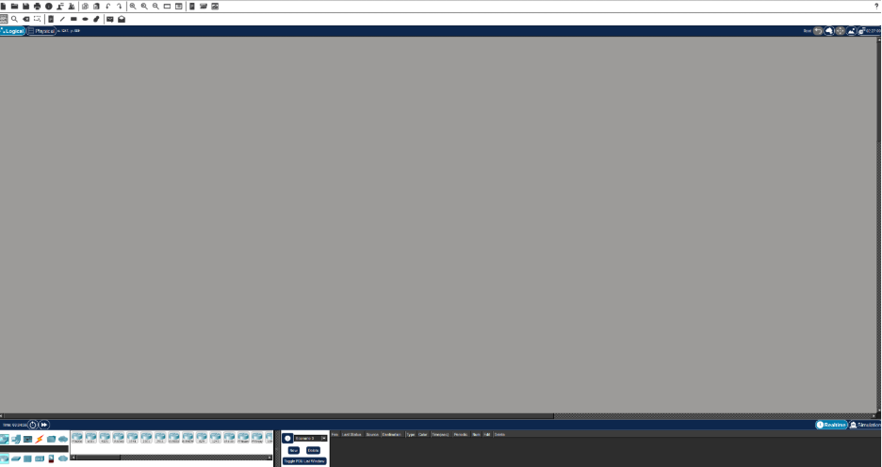
- We Installed and logged in in cisco

Osama placed the PCs, laptops, and switches in their designated locations and organized the network into LAN1 to LAN4 and WAN1 to WAN2.

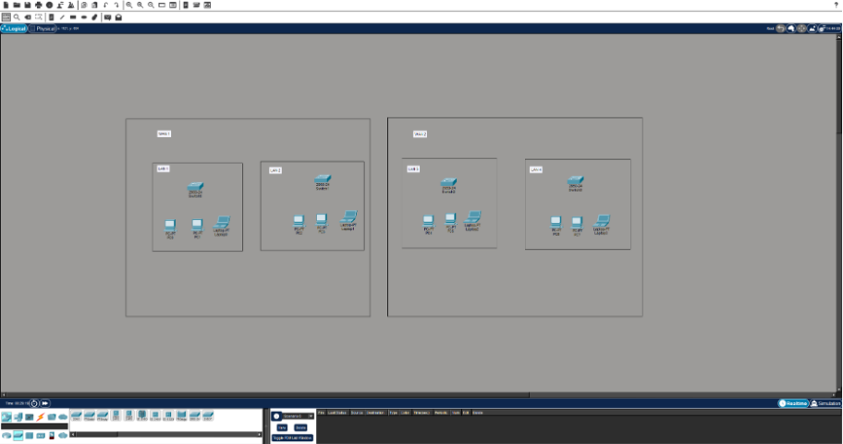

Osama labeled the network as WAN1, WAN2, and LAN1 to LAN4, assigned names to each LAN
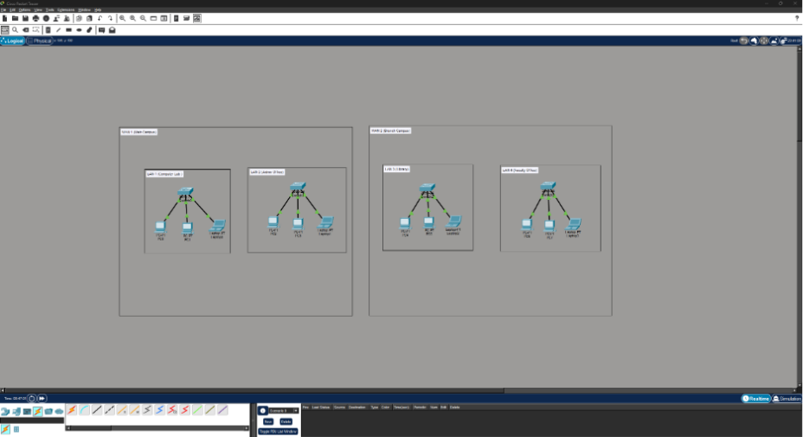
Osama connected each router to its corresponding switches to enable communication across the network.
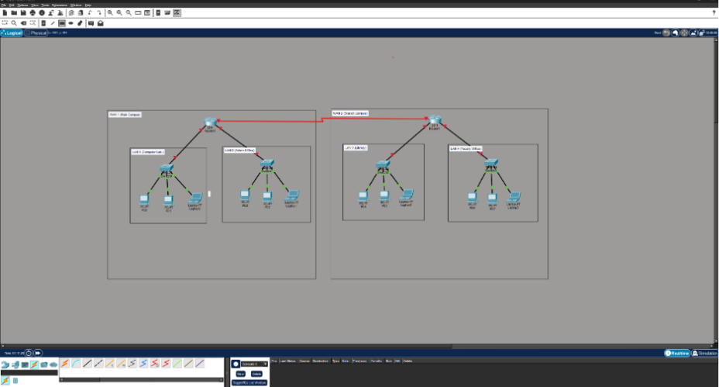

Showing here all ports
